Hospital Information Exchange System

1:Home page of the Website

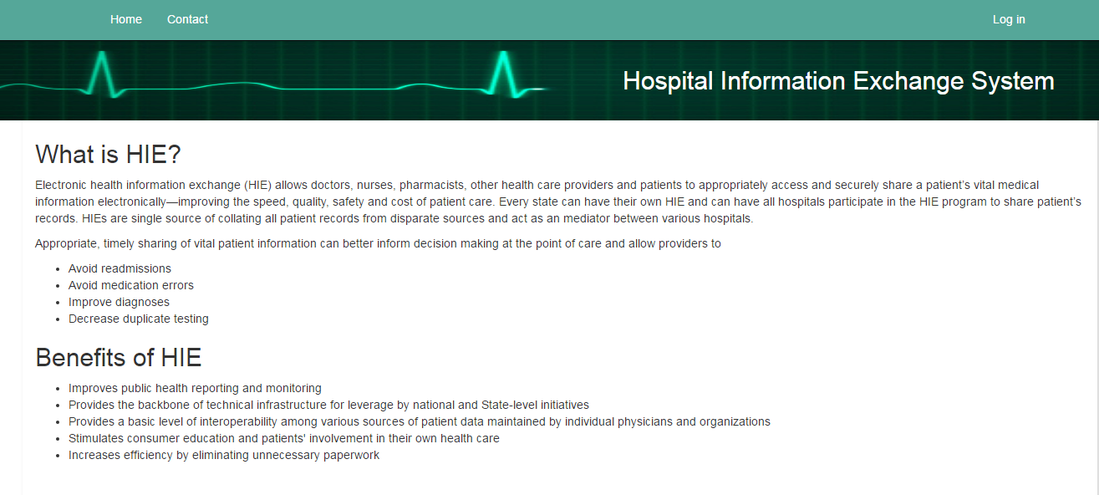

There are two roles 1>**HIE Admin** and 2>**Hospital Admins.** Click Login to log in.

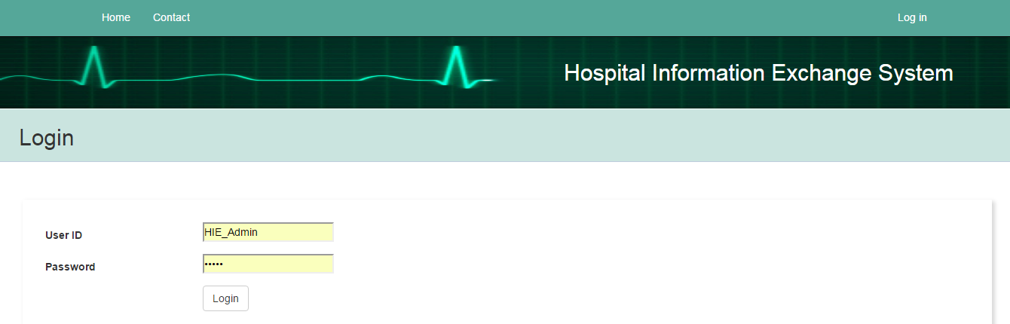

HIE Admin HomePage

HIE Admin will manage complete website and do below main activates

1: Send Enrollment request to all the hospitals, who are not enrolled to HIE system using **Send Enrollment Request** Button.

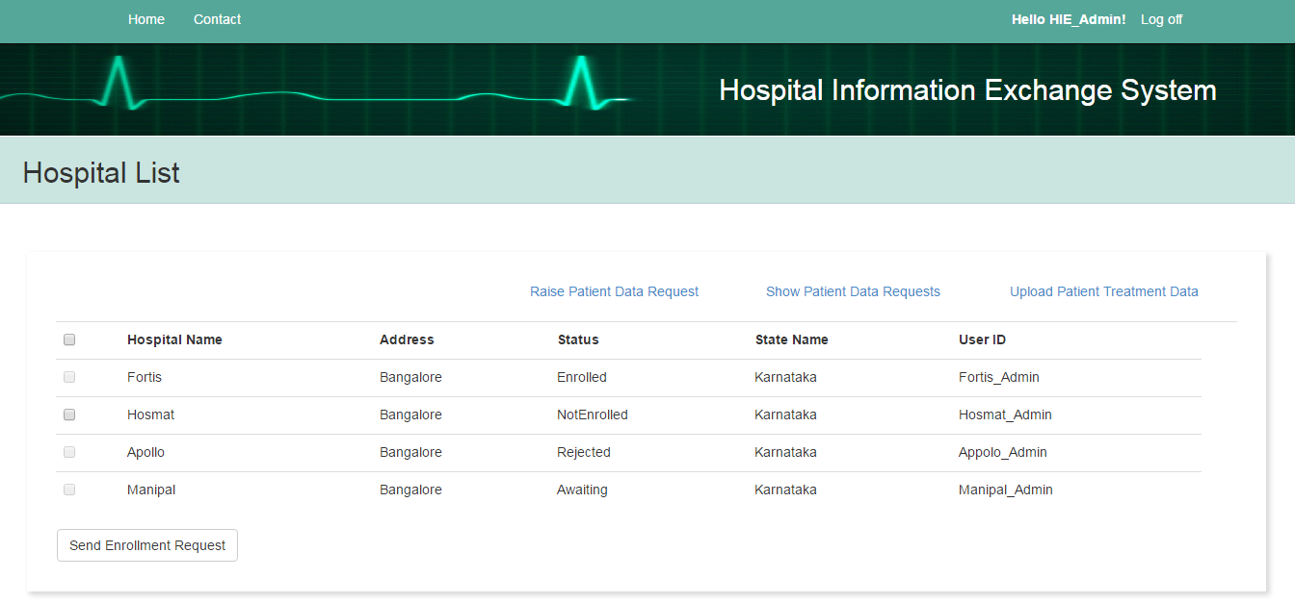

2: Request patient treatment data on behalf of enrolled hospital using [Raise Patient Data Request](http://localhost:49315/PatientDataRequest/Create) and send data back if HIE has it, If not it will send query(**Broadcast Status**) to all other hospital to upload patient information if

they have patient treatment data with them. When the request is fulfilled then HIE admin Close(**Closed status**) the request

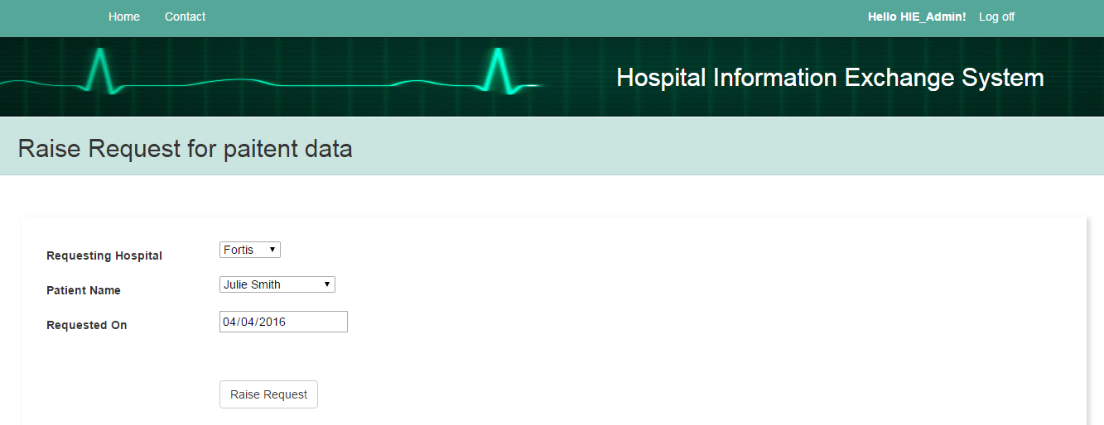

3: [Show Patient Data Requests](http://localhost:49315/HIEAdmin/PatientRequestStatus) link shows all the request raised. .Send request to share patient data to other hospital by using **Request from Other hospital** button, and Close the request if the requested hospital received the required information using **Close Patient Data Request.**

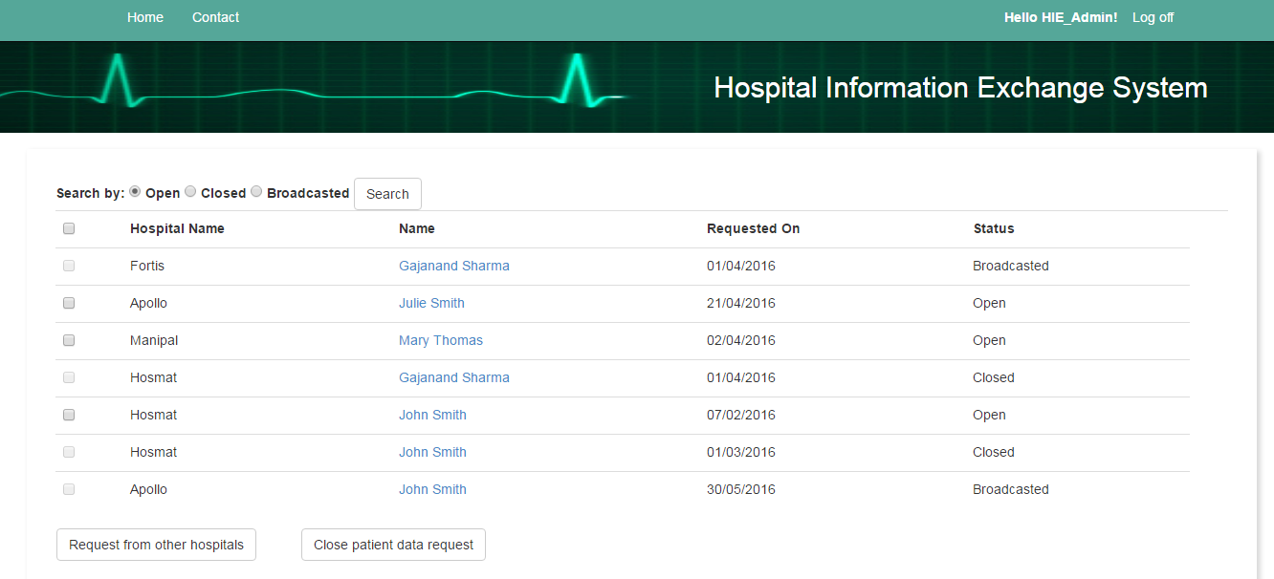

On clicking Patient name link Patient treatment history will be displayed.

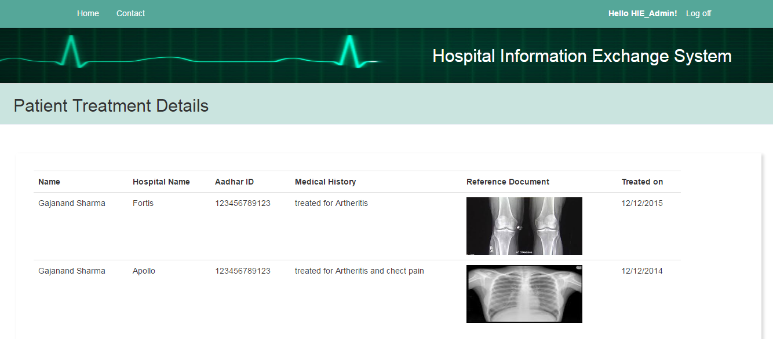

4 : [Upload Patient Treatment Data](http://localhost:49315/PatientTreatmentDetail/Create) link is to Upload patient data in portal.

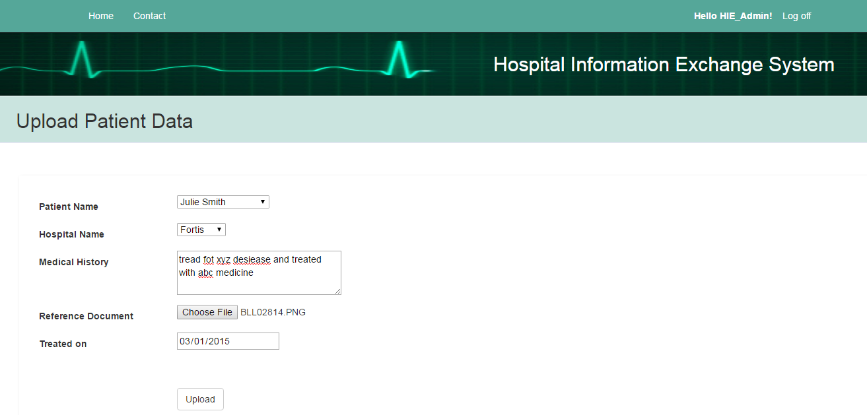

When Hospital Admin Logs in then following home page is displayed based on its status.

If Hospital is Not Enrolled or Rejected the enrollment earlier

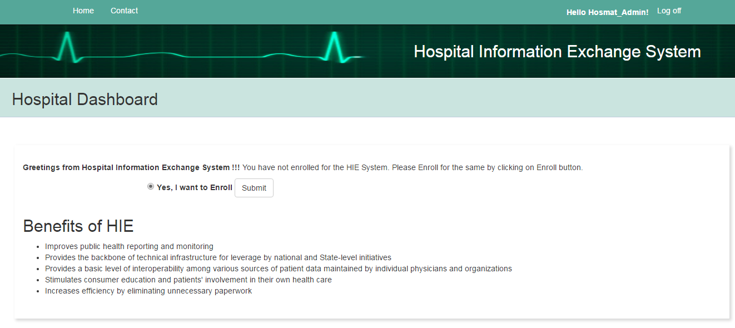

If Hospital is been sent enrollment request by Admin but Hospital has not accepted it .Hospital can accept or reject the enrollment.

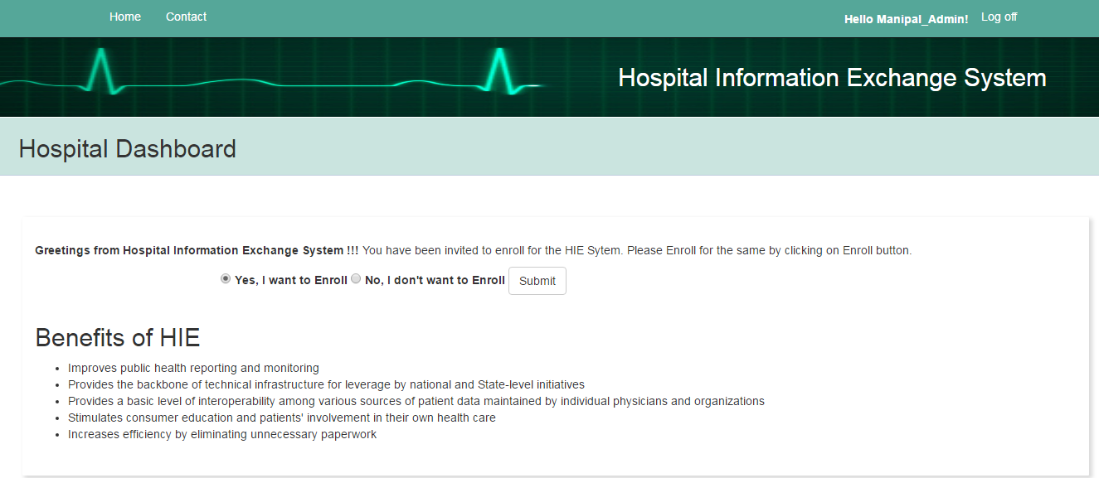

When the Hospital is enrolled following home page comes up

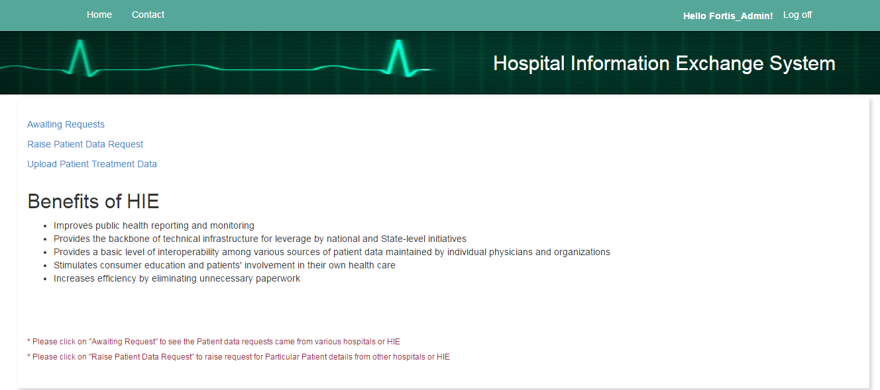

[Awaiting Requests](http://localhost:49315/PatientDataRequest) link takes hospital to the page where all the broadcasted request is shown up which has come from other hospital

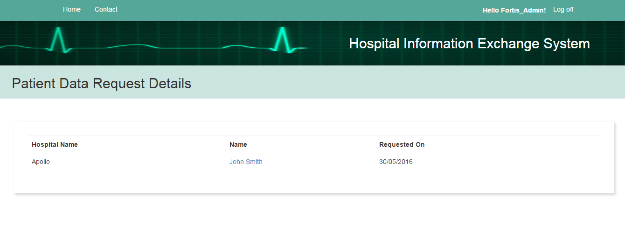

Using [Raise Patient Data Request](http://localhost:49315/PatientDataRequest/Create)**,** Hospital can raise request for any patient from HIE,[Upload Patient Treatment Data](http://localhost:49315/PatientTreatmentDetail/Create) willhelp hospital upload patient data to HIE Portal.